
Name: Janushiya P A
Reg No: 1924260368
Course Code: CSA0224
Course Name: C Programming

TASK 6 – READ AND PRINT DATA CORRECTLY
Bloom’s Level: K3 – Apply

1. Aim
To use scanf() and printf() with correct format specifiers, validate user input, and display electricity bills accurately in rupees and paise.

2. Algorithm
- Start.
- Read the electricity units using scanf().
- Check the return value of scanf() to detect invalid input.
- Calculate the bill in integer paise.
- Convert the total paise into rupees and remaining paise.
- Display the bill using the correct format specifiers.
- Stop.

3. C Program

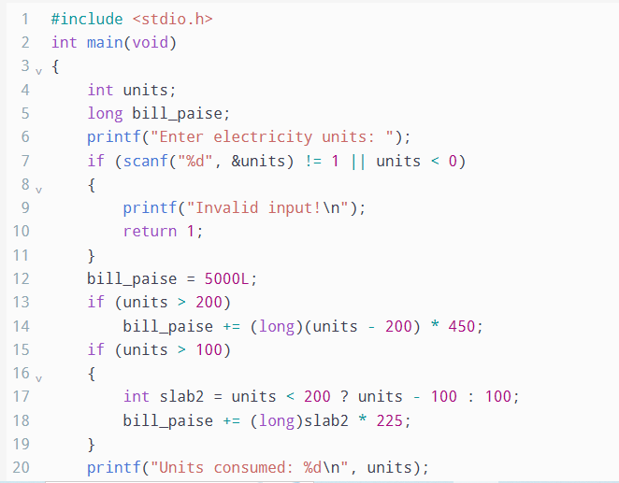

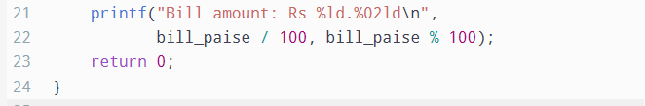

4. Input and Output
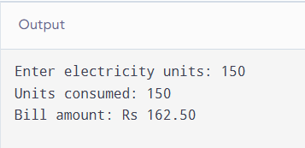

5. Format Specifiers
Data type | Format specifier
int | %d
unsigned int | %u
long | %ld
long long | %lld
float | %f in printf() and %f in scanf()
double | %f in printf() and %lf in scanf()
char | %c
String (char array) | %s

6. Wrong Format Specifier
Using %d to print a long value is incorrect. For example:
long amount = 123456789L;
printf("%d\n", amount); /* Incorrect */
printf("%ld\n", amount); /* Correct */
The incorrect format causes undefined behaviour, so the displayed result may be wrong. The correct specifier for long is %ld.

7. Alternative Concept and Complexity Analysis
An alternative is to read a complete input line using fgets() and then convert it using sscanf() or strtol().
- scanf() reads input directly and checks whether the expected value was converted successfully.
- fgets() reads a line into a fixed-size buffer, and strtol() can validate the converted number and detect extra characters or out-of-range values.
- Processing a line of length (L) takes O(L) time. The buffer requires O(L) space, or O(B) space for a fixed buffer of size B.
- scanf() can leave invalid characters in the input stream, while line-based input makes it easier to discard an invalid line and request new input.

8. Result
The program successfully reads electricity units, validates the input, calculates the bill in integer paise, and prints the amount correctly in rupees and paise using appropriate format specifies.

